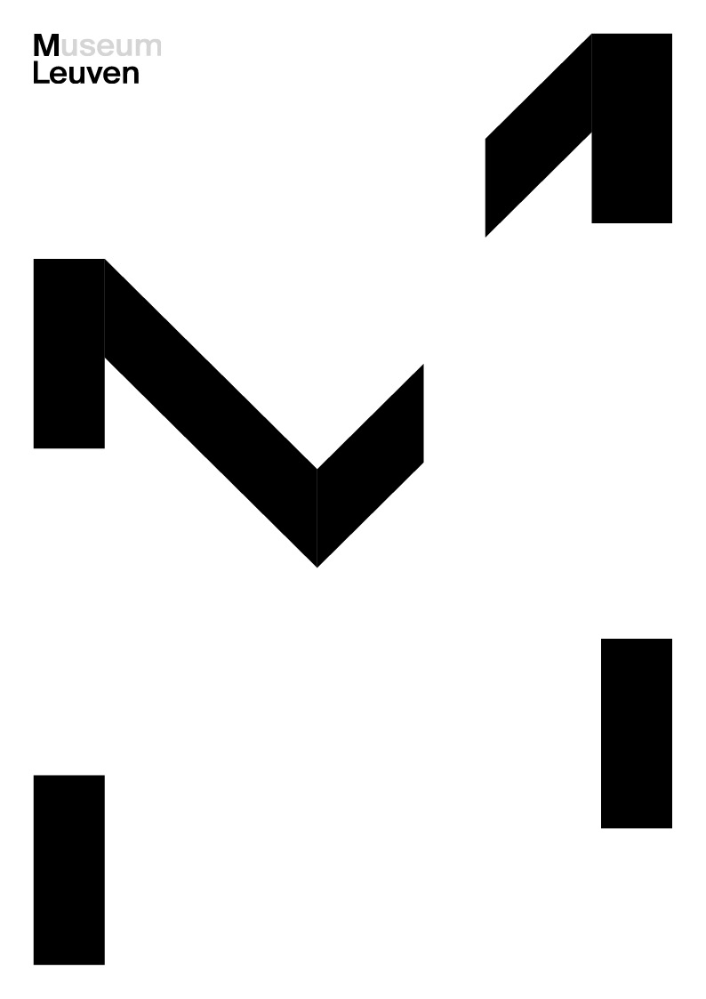

‘THE COLLECTION OF M’

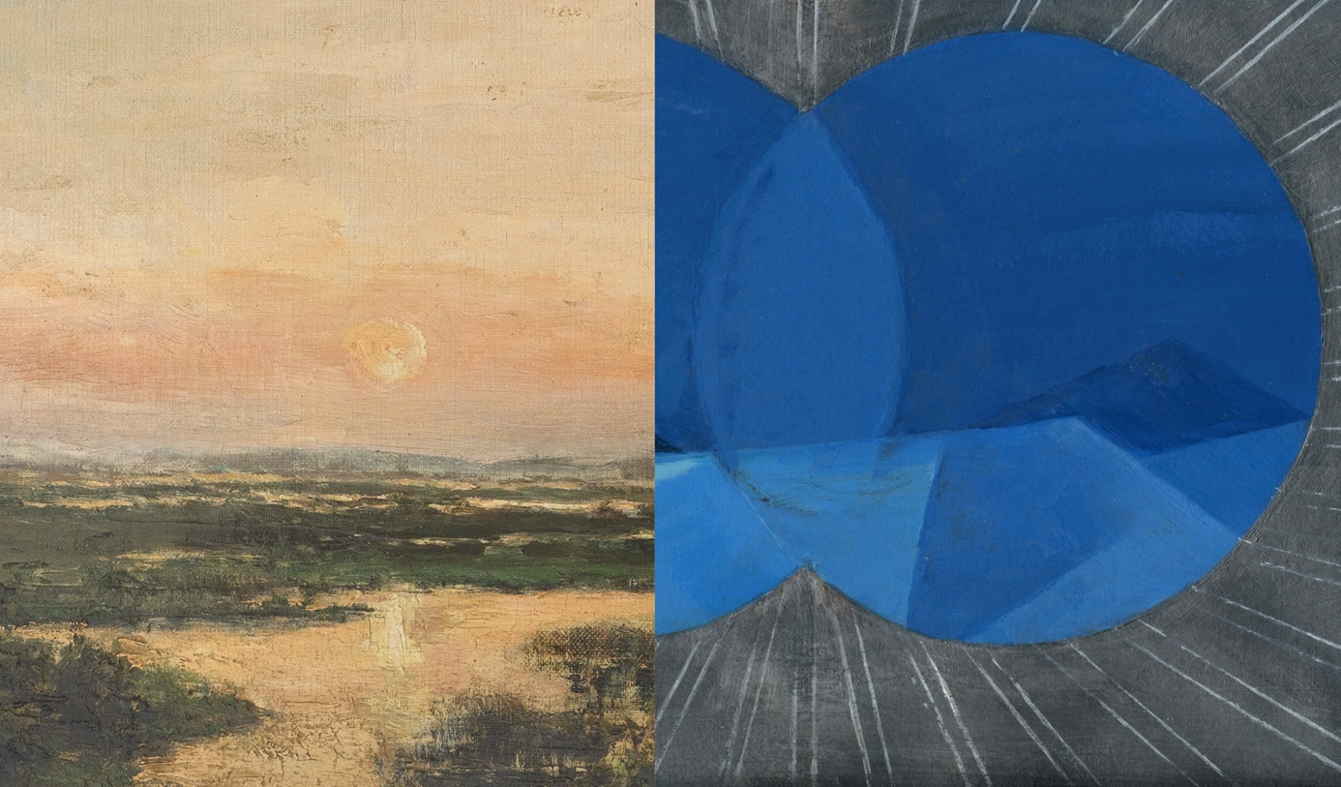
‘Marshes of Genk’ (detail), Rodolphe de Lexhy, 1894, M Leuven Collection, CC0, photo: M Leuven | ‘I Sea’ (detail), Tina Gillen, 2018, Flemish Community Collection at M Leuven, photo: © the artist

Press release
From 29 June 2024, M Leuven will present no less than 300 works from its rich and diverse collection, including many pieces displayed at M for the first time. Both masterpieces and lesser-known gems will guide the audience through unexpected parallels and highlight socially relevant issues. In this way, the museum challenges visitors to view art from a new perspective and draw connections between the past and present. With the opening of the ‘Collection of M,’ coinciding with the ‘Open M | Openly Hidden’ exhibition, M Leuven celebrates the start of summer with its galleries filled with art.
Today, the M collection encompasses over 58,000 objects ranging from the Stone Age to the present day, with strong representations from the late Gothic, Renaissance, and nineteenth centuries. Additionally, M manages a valuable collection of contemporary art, featuring numerous works by artists active in Belgium. In recent years, the collection has expanded significantly with new acquisitions. The collection presentation, opening on 29 June and occupying the entire ground floor of the museum, will showcase both familiar and new pieces, highlighting their rich diversity. Visitors can explore a wide range of mediums, including sculpture, prints, painting, video, ceramics, glass, and photography.

‘The collection that M manages on behalf of the city of Leuven belongs to all of us. This new presentation warmly invites us to rediscover these shared cultural assets—and give them a place in our own lives,’ said Bert Cornillie, Chairman of M Leuven and Leuven's alderman for culture.
Heritage objects from the Middle Ages, contemporary artworks, and many other treasures from various periods engage in a dialogue before the visitor’s eyes. This includes works by artists such as Meunier, Coxcie, Bouts, Braeckman, Gillen, and Vercruysse.
Eva Wittocx, Head of the Department of Contemporary Art at M, says: ‘Century-old art objects illuminate current themes, while contemporary artworks offer fresh perspectives on established visual traditions. This interplay challenges our viewing habits and encourages us to reflect on the art, ourselves, and the world around us.’
How do light and matter interact? How can the passage of time be captured in images? In what ways does the artist reveal themselves through their work? What occurs when you confront a work of art directly? What do you observe, what is absent, and what do you infer? Can an artwork that is 800 years old still offer insights into our contemporary society?
Room-based research projects or ‘conversation pieces,’ along with a supporting programme of lectures, publications, and debates, will sustain reflection over the next five years.
Marjan Debaene, Head of Department of Ancient Art at M, says: ‘M preserves an important collection of medieval and early Renaissance sculpture from Leuven and Brabant. To continually deepen its understanding of these works, M conducts specialised research. M's Passion Retable, for instance, is undergoing detailed examination and restoration. Some of this work will take place in the gallery, so visitors might occasionally encounter researchers or restorers at work.

New acquisitions in the collection presentation
The great strength of the M collection lies in its versatility and its diverse sub-collections, including medieval sculpture, Bouts, Meunier, Belgian contemporary art, and applied arts.
M views this remarkable collection as a dynamic asset—one that evolves continuously across historical periods—and is dedicated to its ongoing enrichment and expansion.
In this way, M has actively acquired significant pieces of ancient and contemporary art in recent years. These include purchases and permanent loans from both governmental bodies, such as the Flemish Community, and (semi)private institutions, ranging from Cera Bank to church councils and private collections.

In recent years, M has elevated the collection and fostered cross-pollination between the ‘old and new.’ The new collection presentation showcases this evolution in all its richness. Below, we highlight several new acquisitions that will be on display for the first time.

Acquisitions

Constantin Meunier, Afdaling in de mijn [Descent into the Mine], ca. 1900
Constantin Meunier, Oude kolenrooier [Old Coal Picker], ca. 1900

M owns an important collection of sculptures and paintings by Constantin Meunier, who worked in Leuven for an extended period (1887-1897). The most recent acquisition includes a painting and a preparatory drawing for one of the depicted figures. They depict a theme not yet represented in M's collection: mine workers waiting at the mine exit. The sketch is noteworthy not only for providing insight into Meunier's working process but also because M currently has few drawings by the artist in its collection.

Leen Voet, Van Gobbelschroy, Bernard Jos, 2022

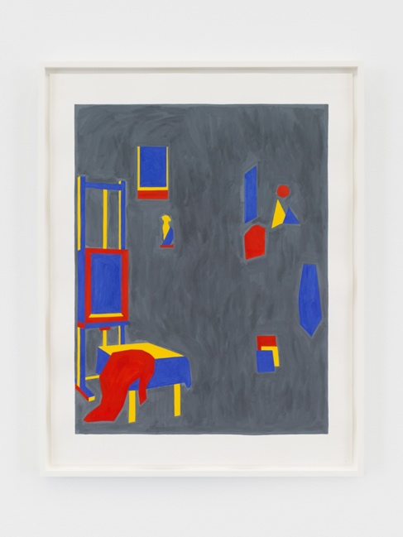
‘Van Gobbelschroy, Bernard’, Leen Voet, 2023, Collection M Leuven, In©,
© SABAM Belgium 2024, photo: Kristien Daem
Leen Voet, Haesaert, Paul, 2022

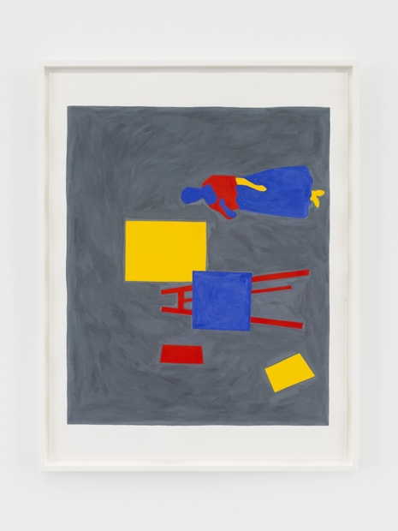
‘Haesaert, Paul’, Leen Voet, 2023, Collection M Leuven, In©, © SABAM Belgium 2024,
photo: Kristien Daem

Leen Voet, Dratz, Constant, 2022

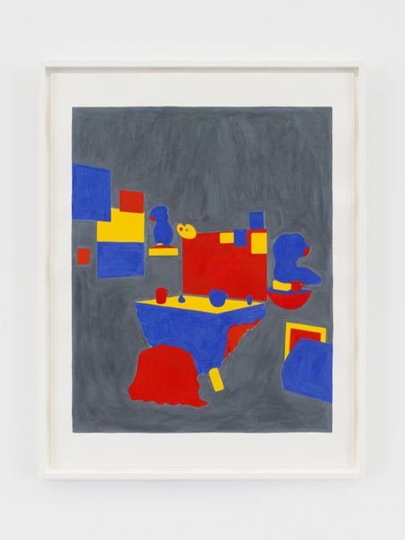
‘Dratz, Constant’, Leen Voet, 2023, Collection M Leuven, In©, © SABAM Belgium 2024, photo: Kristien Daem

These three works by Leen Voet were created for her retrospective exhibition in 2023.
The titles reference a piece from M's collection of ancient art, and each work depicts the studio of a male painter. Leen Voet reflects on these works, contemplating the role of an artist both in the past and today. She reduces the historical studio space to a diagram, focusing on the artworks present and the basic elements of the furniture, executing them in primary colours. Her three works are displayed alternately in the gallery.

Surroundings of Rogier van der Weyden, The Swoon of the Holy Virgin,
c. 1458- 1469

The 15th-century drawing, rendered in brown ink and charcoal on paper, was created in the vicinity of Rogier van der Weyden’s studio and interprets his motif of the Swoon of the Virgin Mary from the Triptych of the Seven Sacraments. Based on the watermark in the paper, the drawing, which may date from the 1460s, also contextualises the work of Dieric Bouts, who was still active in Leuven at the time. In Flemish museums, the number of drawings from this period and of this quality can be counted on less than two hands.

Joannes Josephus Cool, Tea caddy, 1774

Silver tea caddies—tangible witnesses to the popular tea culture of the 18th century—are extremely rare among Belgian manufacturing centres. Only a few examples bearing Leuven hallmarks are known. Additionally, pieces by the Diest silversmith Cool are similarly rare. This tea caddy is a valuable addition to M's distinguished sub-collection of historic Leuven silverware, which features several recognised Masterpieces.

Long-term loans

Pieter Vermeersch, Untitled

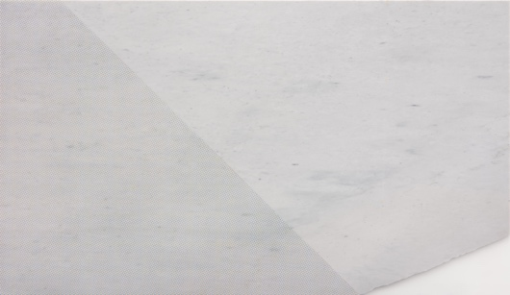
Untitled, Pieter Vermeersch, 2023, Flemish Community Collection at M Leuven, In ©, © SABAM Belgium 2024, photo: courtesy Greta Meert gallery

In his practice, Pieter Vermeersch pushes the boundaries of traditional painting and graphic art. He questions and explores the parameters of these media, working with various materials such as canvas, photography, existing architecture, and marble, as exemplified by this new addition to the collection (Flemish Community Collection at M Leuven). Vermeersch applies screen printing to the marble, adding a new layer to the crystallised time of the material.

Collection Van der Velden-Teurlings

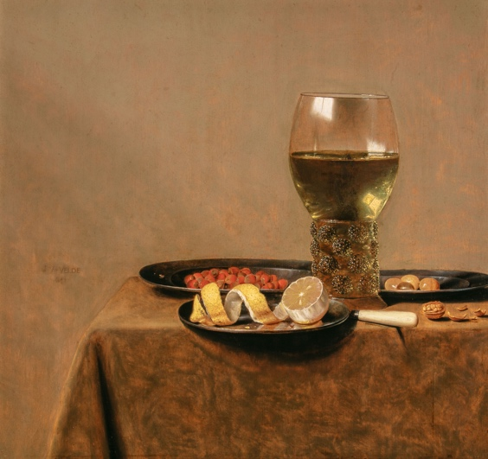
‘Still Life with Roemer of White Wine’, Jan III Van de Velde, 1641, long-term loan Collection van der Velden-Teurlings, public domain, © Collection van der Velden-Teurlings, photo: Pieter de Vries

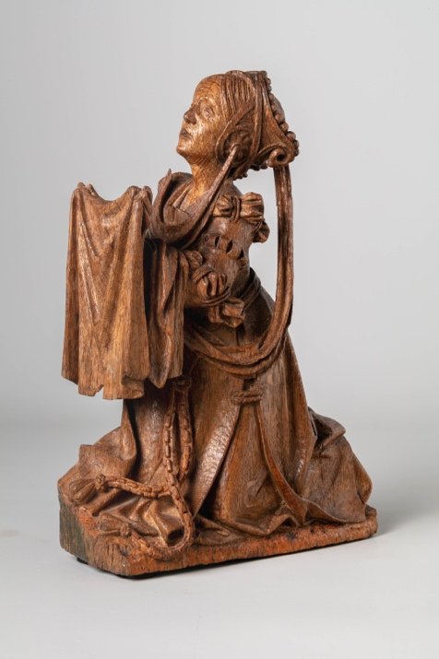
‘Saint Veronica’, Antwerp, c. 1525, long-term loan from the Collection van der Velden-Teurlings, public domain, © Collection van der Velden-Teurlings, photo: Pieter de Vries

The long-term loan from the Van der Velden-Teurlings private collection enriches two sub-collections at M with high-quality pieces. The robust collection of medieval sculpture is geographically enhanced to include religious sculptures from across Europe, while the 17th-century painting collection expands to feature landscapes, genre pieces, and still lifes. From the 73-piece collection, M is now showcasing 25 works for the first time in the new collection presentation. This collection will also be exhibited in its entirety at M in 2025, highlighting the special connection between M and private collectors.

Lili Dujourie, Olivia, 2001

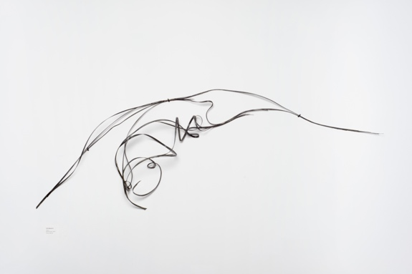
‘Olivia’, Lili Dujourie, 2001, Cera-collection at M Leuven, In ©, photo: Chantal Van Rijt

This new addition to the Cera collection at M Leuven is on display for the first time and is part of a series of similar steel compositions, all named after women. The steel wire composition appears abstract at first glance, but from a specific vantage point, the lines converge to form a portrait of Olivia. Lili Dujourie prompts us to reflect on how women have historically been portrayed in art: posing, reserved, veiled, and often in the background. Dujourie disrupts this historical narrative by placing femininity at the centre of her work.

Koenraad Dedobbeleer, Laymen, 2019

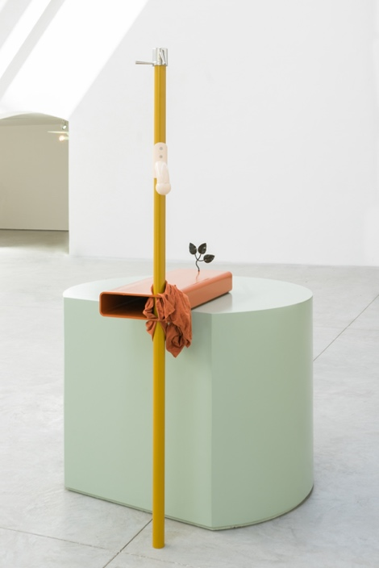
‘Laymen’, Koenraad Dedobbeleer, 2019, Flemish Community Collection at M Leuven, In ©, © Koenraad Dedobbeleer 2024, photo: courtesy Clearing gallery

Koenraad Dedobbeleer's sculpture ‘Laymen’ is a recent addition to the Flemish Community Collection at M Leuven. The materials and shapes used in the work reference interior and industrial design, creating a dialogue with the historical interior of the salon in the House Vander Kelen as part of the new collection presentation.

Vincent Geyskens, I conformisti, 2020

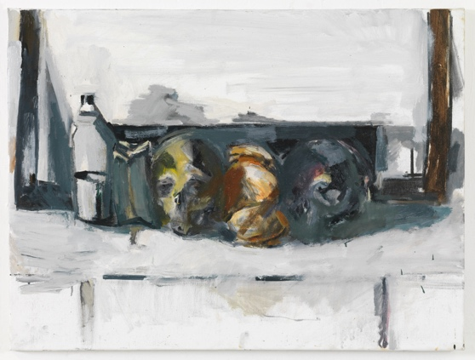
‘I Conformisti’, Vincent Geyskens, 2020, Flemish Community Collection at M Leuven, In ©, © Vincent Geyskens 2024, photo: Lieven Herreman

In the work ‘I conformisti,’ Vincent Geyskens adopts an almost abstract approach to the still life. The vigorous brushstrokes make it difficult to discern the depicted skulls and other objects. As a result, the work appears to hover between figuration and abstraction. The painting was featured in his exhibition at M in 2020 and subsequently entered the M Collection as a loan from the Flemish Community.

Marthe Wéry, Untitled (Ijsselland), 1993

‘Untitled (Ijsselland)’, Marthe Wéry, 1993, Cera collection at M Leuven, In ©, photo: Vincent Everarts, courtesy La Patinoire Royale | Galerie Valérie Bach

This triptych, made of wood, acrylic paint, and varnish, was recently acquired by Cera. This piece, along with other works by Wéry already in the Cera collection, is representative of the artist's oeuvre. In her work, Wéry focused on the painterly exploration of geometry. She created an extensive series of geometric, monochrome canvases, drawing influence from her background in engraving. This focus on exploring the essence of materials became a significant aspect of her work, as exemplified by this triptych.

Van Dyck, Bouts, Benson and Garofalo

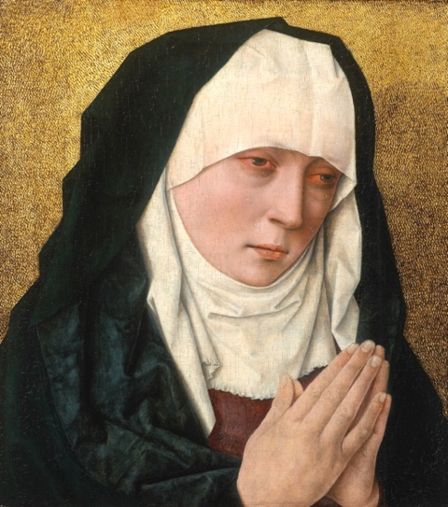
‘Mater Dolorosa’, Albrecht Bouts, after 1490, long-term loan from private collection, public domain, photo: © KIK-IRPA, Brussels

In addition to the remarkable portrait of Marguerite de Lorraine by Sir Anthony van Dyck, which is already on display at M, the museum has recently received several other masterpieces on loan from an important private collection. Among these is Albrecht Bouts' exquisite duo, Mater Dolorosa and Christ Crowned with Thorns. A number of extraordinary 15th-century panels depicting scenes from the life of St Jerome, created by Ambrose Benson, Benvenuto Tisi da Garofalo, and others, will also soon enrich the collection presentation.

Works

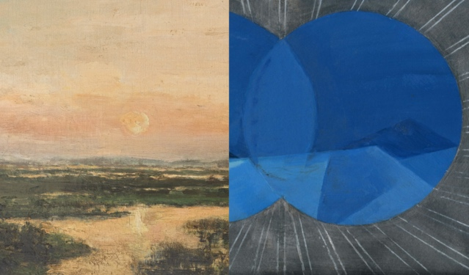 | ‘Marshes of Genk’ (detail), Rodolphe de Lexhy, 1894, M Leuven Collection, CC0, photo: M Leuven | ‘I Sea’ (detail), Tina Gillen, 2018, Flemish Community Collection at M Leuven, photo: © the artist
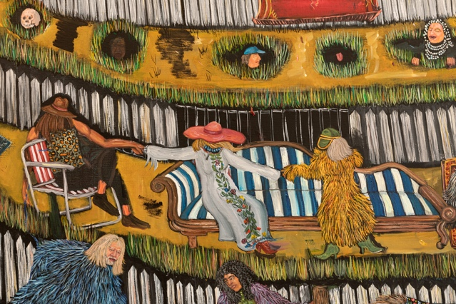 | ‘Hill Theatre’ (detail), 2020-21, Flemish Community Collection at M Leuven, In©, photo: courtesy Tim Van Laere Gallery
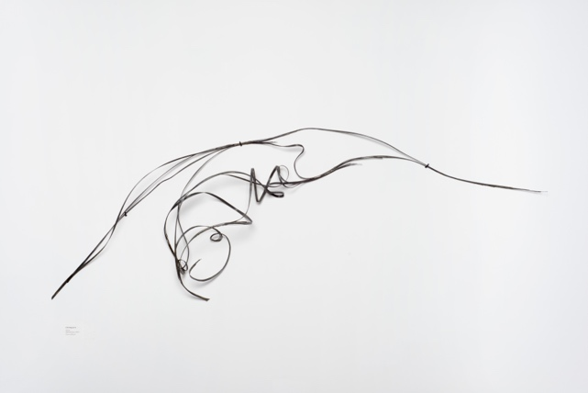 | ‘Olivia’, Lili Dujourie, 2001, Cera-collection at M Leuven, In ©, photo: Chantal Van Rijt
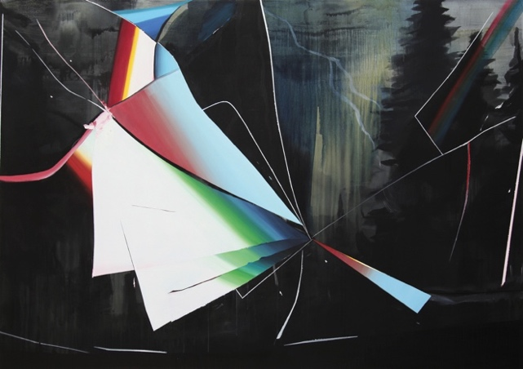 | ‘Rain or Shine’, Tina Gillen, 2013, Flemish Community Collection at M Leuven, In©, photo: the artist
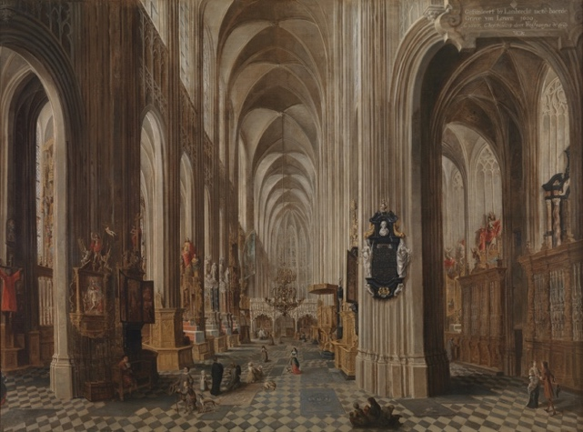 | ‘Interior of St Peter's Church’, Wolfgang de Smet, 1667, M Leuven Collection, CC0, source: artinflanders.be, photo: Dominique Provost
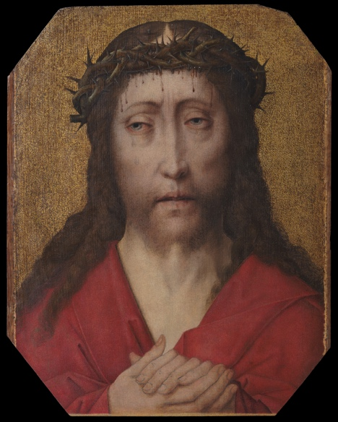 | ‘Christ Crowned with Thorns’, Studio Dieric Bouts, c. 1470, Collection M Leuven, public domain, photo: © KIK-IRPA, Brussels (Belgium)
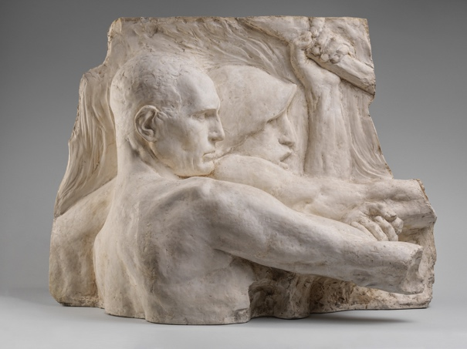 | ‘Model for facade sculpture “Industry”’, Constantin Meunier, 1896, Collection M Leuven, CC0, photo: Cedric Verhelst
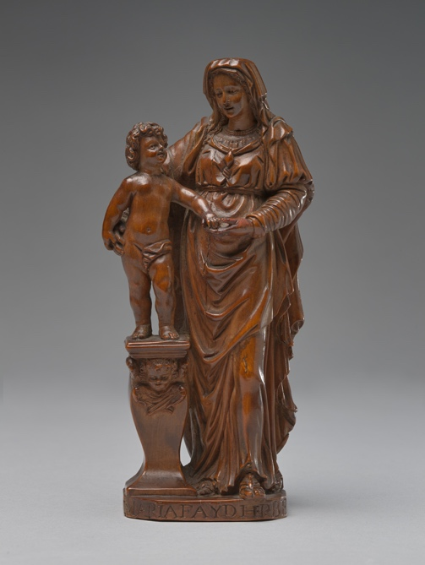 | ‘Mary with Infant’, Maria Faydherbe, c. 1600- 1625, Collection M Leuven, CC0, source: artinflanders.be, photo: Cedric Verhelst
 | ‘Untitled (Ijsselland)’, Marthe Wéry, 1993, Cera collection at M Leuven, In ©, photo: Vincent Everarts, courtesy La Patinoire Royale | Galerie Valérie Bach
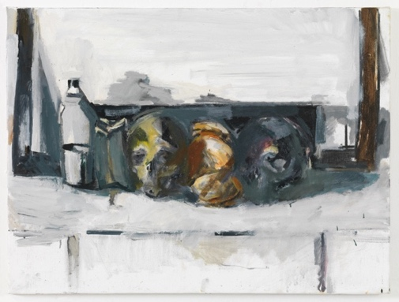 | ‘I Conformisti’, Vincent Geyskens, 2020, Flemish Community Collection at M Leuven, In ©, © Vincent Geyskens 2024, photo: Lieven Herreman
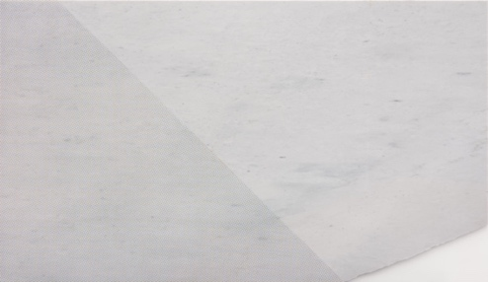 | Untitled, Pieter Vermeersch, 2023, Flemish Community Collection at M Leuven, In ©, © SABAM Belgium 2024, photo: courtesy Greta Meert gallery
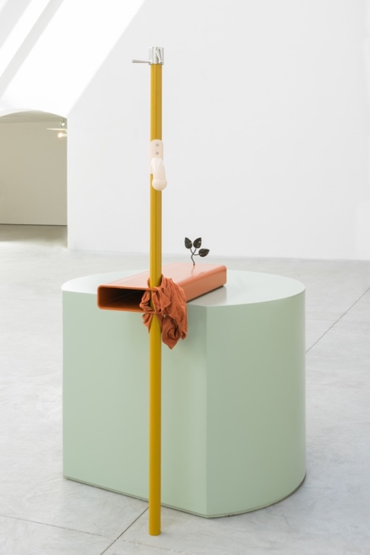 | ‘Laymen’, Koenraad Dedobbeleer, 2019, Flemish Community Collection at M Leuven, In ©, © Koenraad Dedobbeleer 2024, photo: courtesy Clearing gallery
 | ‘Van Gobbelschroy, Bernard’, Leen Voet, 2023, Collection M Leuven, In©, © SABAM Belgium 2024, photo: Kristien Daem
 | ‘Haesaert, Paul’, Leen Voet, 2023, Collection M Leuven, In©, © SABAM Belgium 2024, photo: Kristien Daem
 | ‘Dratz, Constant’, Leen Voet, 2023, Collection M Leuven, In©, © SABAM Belgium 2024, photo: Kristien Daem
 | ‘Mater Dolorosa’, Albrecht Bouts, after 1490, long-term loan from private collection, public domain, photo: © KIK-IRPA, Brussels
 | ‘Still Life with Roemer of White Wine ’, Jan III Van de Velde, 1641, long-term loan Collection van der Velden-Teurlings, public domain, © Collection van der Velden-Teurlings, photo: Pieter de Vries
 | ‘Saint Veronica’, Antwerp, c. 1525, long-term loan from the Collection van der Velden-Teurlings, public domain, © Collection van der Velden-Teurlings, photo: Pieter de Vries

PRACTICAL INFORMATION
Address

M Leuven
Leopold Vanderkelenstraat 28
3000 Leuven
www.mleuven.be

Plan your route to the museum

By bicycle
All cyclists are welcome. You can easily and safely park your bike in the bike park under Rector de Somer Square. From there, it's just a two-minute walk to the museum.

By public transport
The museum is a ten-minute walk from Leuven station. If you're coming by bus, Rector de Somerplein is the nearest stop. Plan your route using Google Maps.

By car
The new circulation plan guides you to Leuven and its car parks in several loops. Prefer to avoid city traffic? Park in one of the peripheral car parks and take the free bus to the city centre. If you prefer to park closer, car park Ladeuze is just a two-minute walk from the museum. There are also 18 parking spaces available for people with disabilities (parking height: 1.90m).

Press contacts

Nica Broucke, press & PR
nica.broucke@mleuven.be
0495 28 63 05

Ellen Verhelle, press & PR
ellen.verhelle@mleuven.be
0479 97 76 36

